Assignment 01
Name: K Ashwitha
Hall ticket Number -2303A52216
Batch -45

Task 1: AI-Generated Logic Without Modularization (String Reversal Without Functions)

Prompt :
Create a Python program to take a string from the user and print the reversed string without using any functions.

Code :
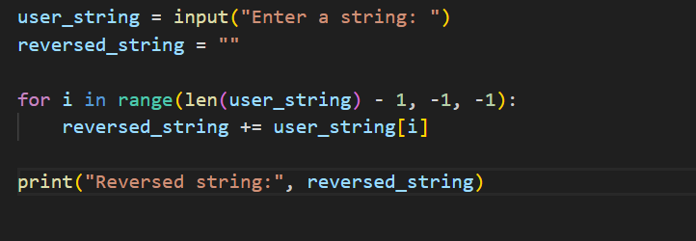

Output :
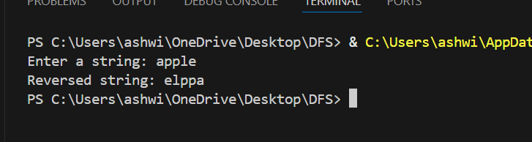

Justification :
This code asks the user to enter a string and then reverses it step by step.
It starts reading the string from the last character and moves towards the first.Each character is added to a new string in reverse order.
No functions are used, so the logic is easy to follow and understand.
Finally, the reversed string is printed on the screen.

Task 2: Efficiency & Logic Optimization (Readability Improvement)

Prompt:
Optimize the Python string reversal code.Remove extra variables, simplify the loop logic, and make the code easy for others to read and understand.

Code:
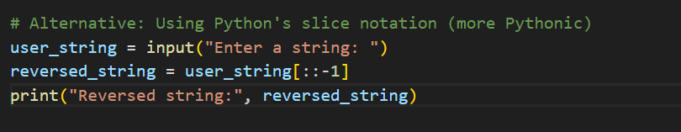

Output:
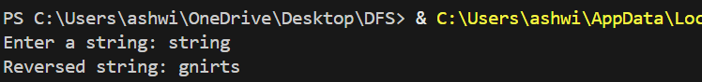

Justification :
The improved code removes extra steps that are not needed. It uses a simpler way to reverse the string, so the code looks cleaner. This makes it easier for other developers to understand. The program runs faster because it avoids unnecessary looping work. Overall, the code is short, clear, and efficient.

Task 3: Modular Design Using AI Assistance (String Reversal Using Functions)
Prompt:
Create a Python program using a user-defined function to reverse a string.The function should return the reversed string.Add clear and meaningful comments so the code is easy to understand.
Code:
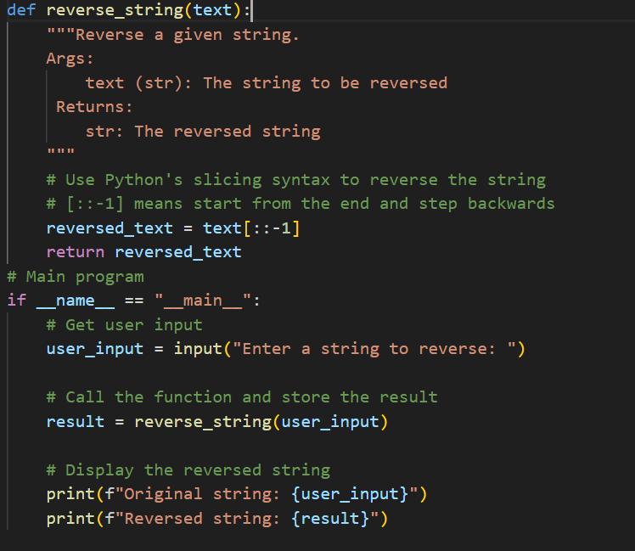

Output:
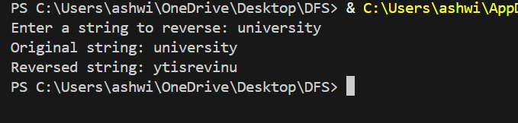

Justification:
Using a function allows the same string reversal logic to be used in many places.The function takes a string, reverses it, and returns the result.
Comments help explain what each part of the code does.This makes the program easy to read and maintain.Overall, the code becomes organized and reusable.

Task 4: Comparative Analysis – Procedural vs Modular Approach (With vs Without Functions)

Prompt:
Compare the Python programs for string reversal written without functions and with functions.Analyze which one is better in terms of code clarity, reusability, ease of debugging, and use in large applications.
Provide a short report or table showing the comparison.

Code:

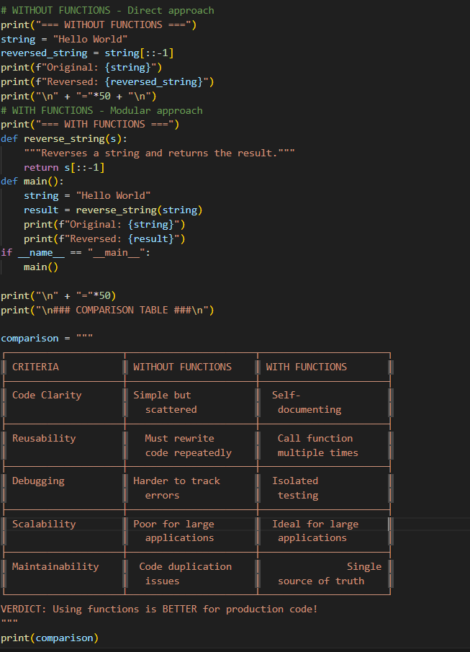

Output :
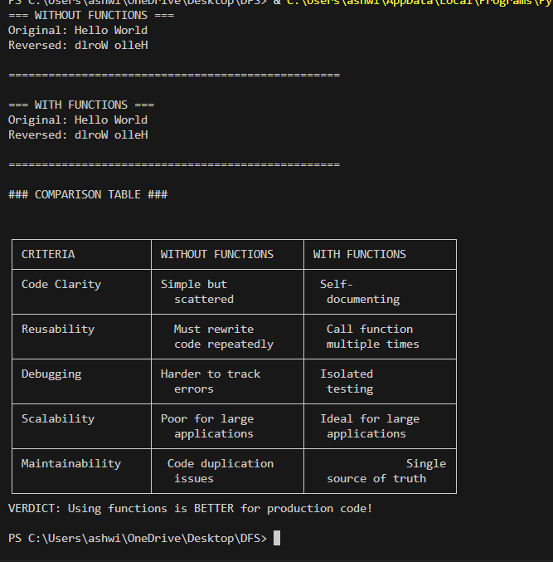

Justification:
The code without functions is okay for small tasks but gets messy when it grows.Code with functions is cleaner and easier to read.Functions can be used again in many places.It is easier to find and fix mistakes in function-based code.For bigger projects, using functions is much better.

Task 5: AI-Generated Iterative vs Recursive Fibonacci Approaches (Different
Algorithmic Approaches to String Reversal)

Prompt :
Generate two Python programs to reverse a string:1. Using a loop (iterative approach) 2. Using Python built-in features or slicing .Compare them by explaining how they work, their time complexity, performance for large inputs, and when each approach should be used.

Code :
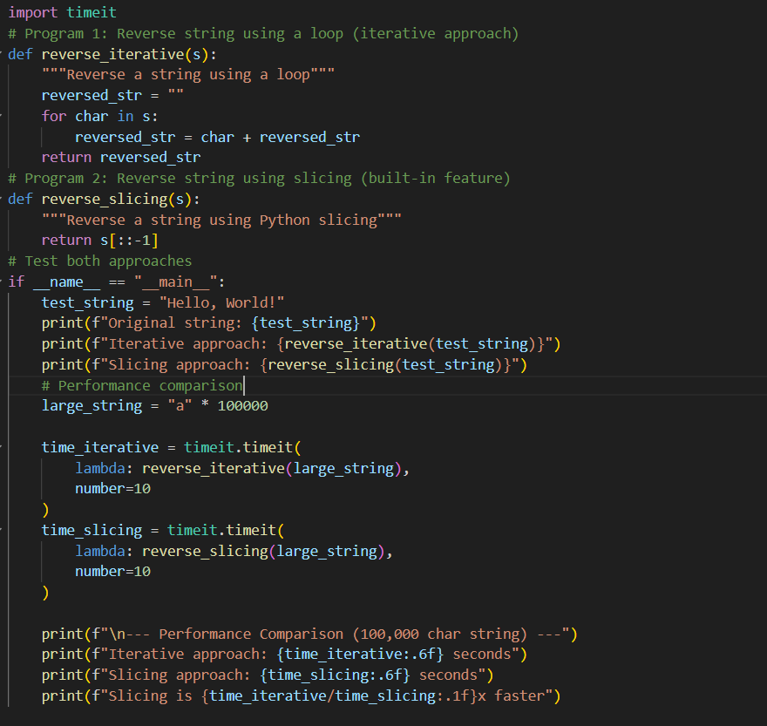

Output:

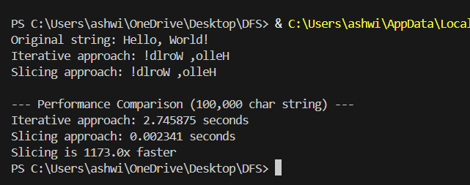

Justification :
The loop-based approach reverses the string step by step and is easy to understand.
The built-in or slicing method does the reversal in a single line and is faster.
Looping is good for learning and small programs, while slicing is better for large inputs and real applications.
Both approaches produce the same result, but slicing is more efficient and cleaner.

